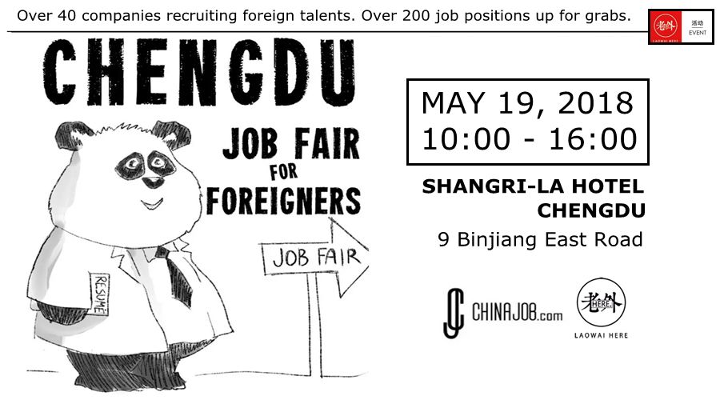

After receiving the approval from the State Administration of Foreign Experts Affairs, a large-scale job fair focused on the recruitment of foreign talents shall be held in Chengdu this May!
Message from Laowai Here
“We are thrilled to announce the full line-up for this year's Job Fair for Foreigners in Chengdu.
Scroll down to browse these fantastic job positions across an extensive range of industries.
Over 40 companies recruiting foreign talents. Over 200 job positions up for grabs.

What are you waiting for? See you at the Shangri-La Hotel on Saturday 19th May!”
---- LAOWAI HERE Team
Consultancy Wechat: herelaowai001

May 19, 10:00-16:00 (Saturday)
Shangri-La Hotel Chengdu
9 Binjiang Dong Road

Reasons to Attend the 2018 Chengdu Job Fair for Foreigners:

1. MAKE CONTACT WITH PEOPLE
You can make valuable contact with people from different backgrounds. Don't miss the chance to expand your network of interpersonal relationship!

2. DO JOB MARKET RESEARCH
The job fair will offer you precious information on the career opportunities in Chengdu.

3. GET NEW IDEAS
Face-to-face talks with HR managers and other job-seekers at the scene will give you new perspectives and information. And you might meet someone who will inspire you to try something new!

4. GAIN EXPERIENCE
You can talk to potential employers, which gets you better prepared in the job market in the future.

Company & Positions List

HR & Manufacturing


Laowai Here
Positions across Human Resources & Recruitment, IT, Hospitality, Medicine, Engineering, Science, Education, Finance, Design industries and more, including:

- Assistant Consultant
- Marketing (New Social Media) Coordinator
- Risk Control Manager
- Business Development Manager
- Industrial Design Director
- R&D Director
- International Kindergarten Principle
- Academic Manager – High School

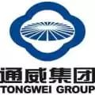
Tongwei Group
- Supplier Manager
- International Marketing Manager
- R&D Engineer
- R&D Manager
- Senior Process Engineer
- Chlorine Product Development Engineer

Aero HR Holding
- Senior Officer


Y&J Industries
- Foreign Trade Salesman


Harley-Davidson
- General Manager
- Technician


Honghua Group Limited
- Sales Engineering
- Technology Manufacturing - Oil & Gas Equipment


Foreign HR
Positions in Teaching, Marketing, Media, Finance, Engineering, R&D and Technology (50 positions) Including:
- Senior Consultant (education)
- ESL Teacher
- Library Coach
- English Literature Teacher
- Kindergarten& Primary Teachers
- Junior High English Teacher
- Marketing Manager - Australia, Philippines, Pakistan, Russia, South Africa, Nigeria, Kazakhstan, Tunisia, Vietnam, Indonesia, Taiwan, Colombia (construction, mining, energy equipment)
- Regional Manager – S America/SE Asia (plastic piping)
- Sales Manager – Russia (plastic piping)
- Interpreter – English/Chinese (finance)
- Project Manager – IT (automotive)

Foreign Experts Service Center of Shanxi Province
- Positions in Technology, Teaching & Translation (50 positions)


Hello Career
- Country Manager (Real Estate)
- Project Executive Manager
- New Product Development Project Manager (Battery-pack)
- Sales Manager (Die Casting Machine)
Jiangsu Jiulan New Energy Technology Co.,Ltd.
- Director of R&D Project: 2
- Director of R&D of aluminum plastic composite film: 2
- Chief Engineer of Equipment R & D: 1
- Project Director of structural parts: 2

IT & High-Tech

Tap4fun
- Game Community Operator
- Game System Designer
- Concept Artist
Timemaker Crystal Technology
- Product Design Engineer

Future
- Overseas Digital Marketing Manager
- Google SEO Specialist


Ubisoft
- Data Scientist
- Concept Artist
- Model Artist
- QA Engineer
- Technical Animator
- Technical Artist
- VFX Artist
- Animator


Mercku
- Marketing Manager
- Brand Manager
- Business Development Manager
- Advertising Manager
- Social Media Manager
- Marketing Associate
- Brand Associate
- Business Development Associate
- Advertising Associate
- Social Media Associate


CIeNET Technologies (Beijing)
- LTE/5G Software Designer (L1/L2/L3)
- Android Designer
- C++/QT/Linux Developer
- Ruby Developer


Huawei
Multiple positions, global locations.
- Account Manager
- Product Manager
- Channel Retail Manager
- Marketing Manager
- Network Technology Engineer
- Financial Specialist
- HR Specialist
- Procurement Engineer
- Legal Specialist
- Supply Chain Management Engineer


BOE Technology Group
- Fire Protection Engineer
- OLED Array Engineer
- OLED Cell Engineer
- OLED Even Engineer
- Automation Engineer

iLumintel
- CTO
- R&D Director
- Senior Software Architect
- Algorithm Engineer
- VP – HR & Administration Department
- CHO
- Administrative Director


SipingSoft
- IT – Java
- SAP/SAP PLM


Sefon Software
- Sales Manager – Software

Medicine


WestChina-Frontier Pharma Tech
- Marketing Manager
- Project Director
- Quality Assurance Inspectors


HitGen
- Associate Director of Medicinal Chemistry
- Biologist (Cellular Biology)
- Senior Chemist
- Chemist
- Assistant Chemist
- Associate Director
- Principle Scientist
- Scientist
- Assistant Scientist


Brilliant Pharmaceutical
- Quality Control Researcher
- Formulation Researcher

Hospitality & Other

Neptune Hotel
- Restaurant Guest Relation Office

Yagao Meihua Hotel
- Guest Service Manager
- Guest Service Officer – Internship
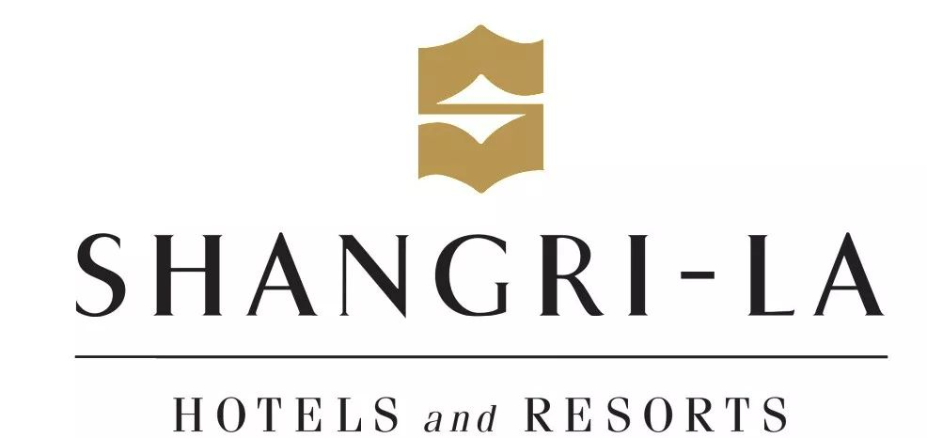
Shangri-La Hotel
- Media Manager


Anbound Consulting
- English Editor


Startupbootcamp
- Program Director
- Program Manager

Leba Technology
- Overseas Market Development Consultant
- Overseas Purchasing Manager
- English Customer Service

United Innovation Services Corp
- Project Manager

DAO·Pureland Cultural Investment
- Graphic Designer
- Landscape Designer
- Urban Planner
- Interactive Designer
- Public Art Designer

Jiangsu Saintlan Garment Co., Ltd
- Costume Designer : 2

Media & Education


CCTV
- Foreign Edition - English & Arabic

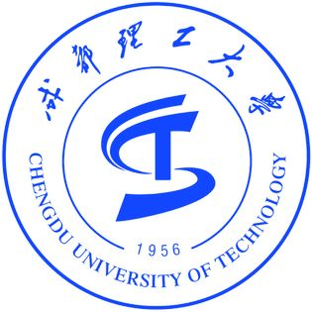

Sino-British Awards at Chengdu University of Technology
- Program Award Leader – Accountancy
- Business Tutor
- English Language/Study Skills Support Tutor

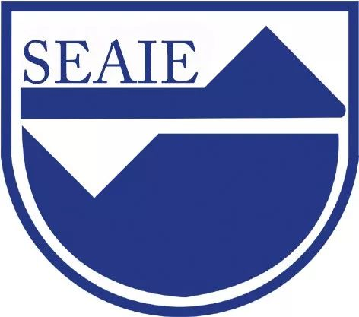
Sichuan Education Association for International Exchange
- University Teacher
- Primary School Teacher
- Kindergarten Teacher

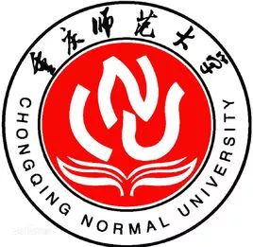
Foreign Trade and Business College of Chongqing Normal University
- English Teacher

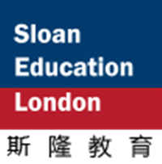
SloanEducation
- Marketing



Cogdel Education Group
- Foundations of Business & ESL Teacher
- Literature and Social Science Teacher
- Chemistry/Physics Teacher
- EAP/Academic English Teacher
- Economics& Business Teacher
- History Teacher
- Music/AP Music Theory Teacher
- Art/AP Art History Teacher


Montessori Bilingual Kindergarten
- Montessori Teacher

Montessori Academy
- Montessori Teacher


Montessori School of Shanghai
- Campus CEO
- Head of School
- Academic Director
- Montessori Sponsorship

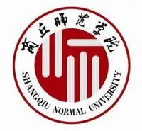
Shangqiu Normal University
- English Teacher


International Institute of Education (i2)
- Teacher

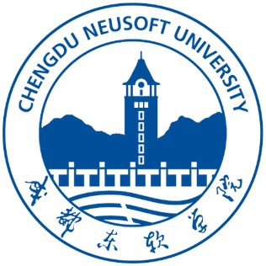
Chengdu Neusoft University
- Computer Correlation Teacher
- Digital Art Teacher
- English and/or Japanese Teacher
- Economy and/or Marketing Teacher

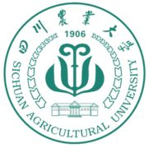
Sichuan Agricultural University
- English Teacher


Inner Mongolia Little London English School
- English Teacher

Hengbaixuyi Culture Communication
- Customer Manager
- Copywriter
- Graphic Designer
- Business Manager

The event is being held by the State Administration of Foreign Experts Affairs and Laowai Here – International HR Service Platform in response to the ever-growing demand for foreign talents to work in enterprises across China.
There will also be:
  - Talks throughout the day on foreign policy analysis, such as visa issues and subsidies available for recruiting foreign talents;
  - Expert consultants available to help go over any job hunting queries you might have.

Q & A

Question 1:
“Hi! I’m a foreign talent looking for new opportunities. How do I sign-up?”

Answer:
Easy. Scan the QR code below and fill in the sign-up form. We will have a registration desk with name lists of registered attendees at the entrance of the event.
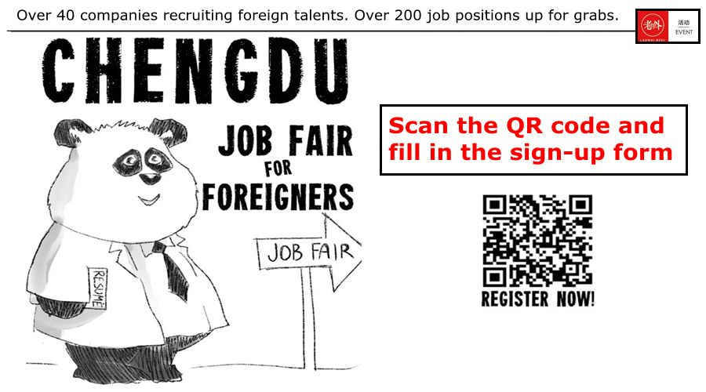

Question 2:
“Where is the Shangri-La Hotel? How do I get there?”

Answer:
The exact event location address is:
成都市锦江区滨江东路9号成都香格里拉大酒店
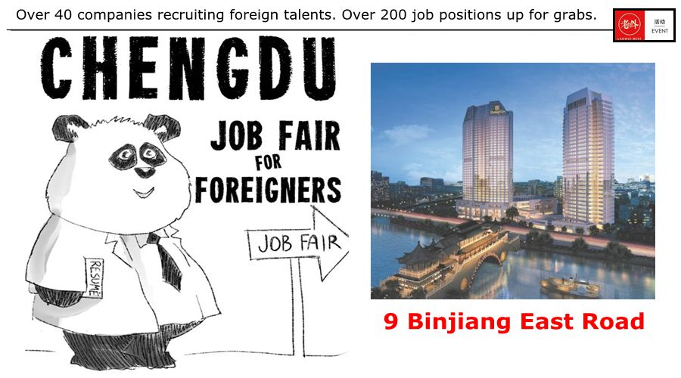

One you enter the hotel, there will be signage and volunteers directing you to the room location.

Here’s our little walkthrough on how to get to the event venue!

By Taxi/Didi:
Either copy-and-paste the Chinese address above into your car hailing APP or show the address to a local taxi driver – they shall all be familiar with where to go.
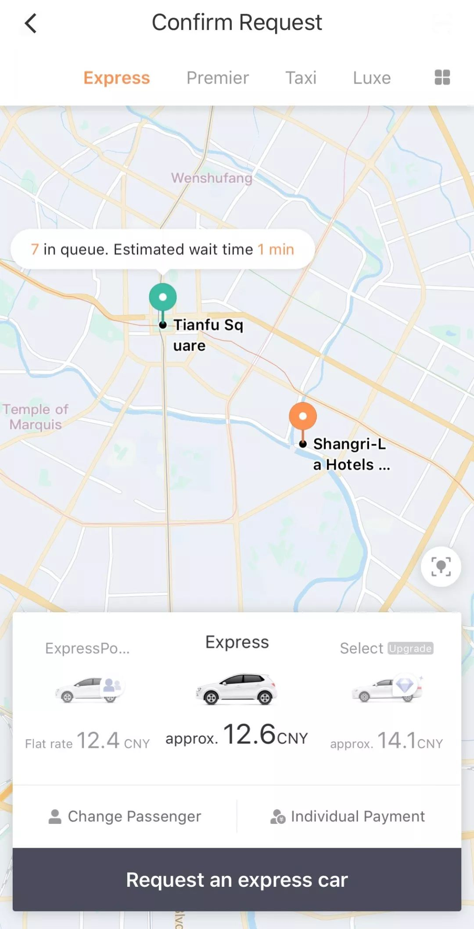

By Metro:
The closest metro station is Line 2’s Dongmen Bridge. Shangri-La Hotel is an 800m walk from the metro station (closet exit is Exit B). See the walking route below.
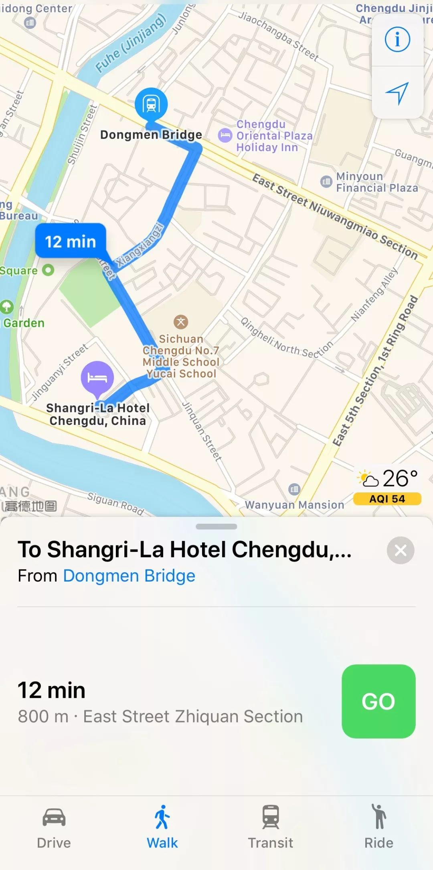

By Bus:
Bus number 92 (toward WuGui Qiao GongJiao Zhan); number 74 (toward XinHong NanLu Zhan); number 82 (toward ChengRen GongJiao Zhan). For all buses, alight at Jiuyanqiao.

Question 3:
“I’m not in Chengdu. Can I still participate?”

Answer:
If you’re not in Chengdu, we still recommend filling in the sign-up form and forwarding your CV. However, companies are looking to meet potential candidates face-to-face, so we advise attending in-person if at all possible.

Question 4:
“I don’t have a printer, but feel I should bring copies of my CV. Where can I print?”

Answer:
Try and prepare as many copies as you can beforehand (there's a lot of companies!) but rest assured, we will have a complimentary CV printing service at the event. We suggest jazzing-up your CV in preparation, adding any new and relevant job/education experience, and perhaps even catering a few different CVs specifically for some of the job positions shown above. Remember your CV and references are likely to be cross-referenced to ensure authenticity – please avoid falsifying any documents.

Question 5:
“What’s ‘Laowai Here’?”

Answer:
Laowai Here is an International HR Service Platform. We offer four main services: Foreign Talent Headhunting, Expat Life Service, Cross-cultural Events, and Expat Business Consultancy. For more information, please add our WeChat: herelaowai001.

REGISTER NOW
Are you ready for Chengdu’s biggest ever foreign talents job fair? Then sign-up now.
