Subscribe to DeepL Pro to edit this document.
Visit www.DeepL.com/pro for more information.
Exclusive Medical Services—Sichuan Taikang Hospital's Specialized Medical Department
Cross-border Medical Care: How to Overcome Language Barriers?
When a family member falls ill and you seek overseas medical advice, how do you connect?
Tired of enduring lengthy queues when seeking medical care?
Craving more attentive and efficient healthcare services?
...
Sichuan Taikang Hospital's Specialized Medical Services Department offers a transformative healthcare experience.

Beyond mere "cure," we focus on "holistic wellness."
Built on international standards and leveraging the strengths of the Taikang healthcare ecosystem, the Specialized Medical Department at Sichuan Taikang Hospital establishes Sichuan as a medical destination connecting global healthcare resources and delivering comprehensive, personalized health management services. Breaking down traditional departmental barriers, we provide "one-stop" health management services covering the entire life cycle.
Comprehensive and Precise Deep Health Checkups: Leveraging top-tier imaging and laboratory equipment, we offer precision health screening packages. Senior expert teams interpret reports, not only identifying potential health risks but also providing detailed health risk assessments and lifestyle guidance—shifting the focus from treating existing illnesses to preventing future ones.
Multidisciplinary Team (MDT) Approach for Complex Conditions: For challenging diseases like oncology, cardiovascular, and neurological disorders, we assemble experts from surgery, internal medicine, imaging, and other fields to develop optimal treatment plans. Leveraging Taikang Healthcare's national and international network, we facilitate remote consultations with leading domestic and international specialists, ensuring cutting-edge and precise medical decisions.
3H Management: Patient-centered care delivered through our 3H approach—high-quality medical resources, hotel-style services, and a warm, home-like environment.
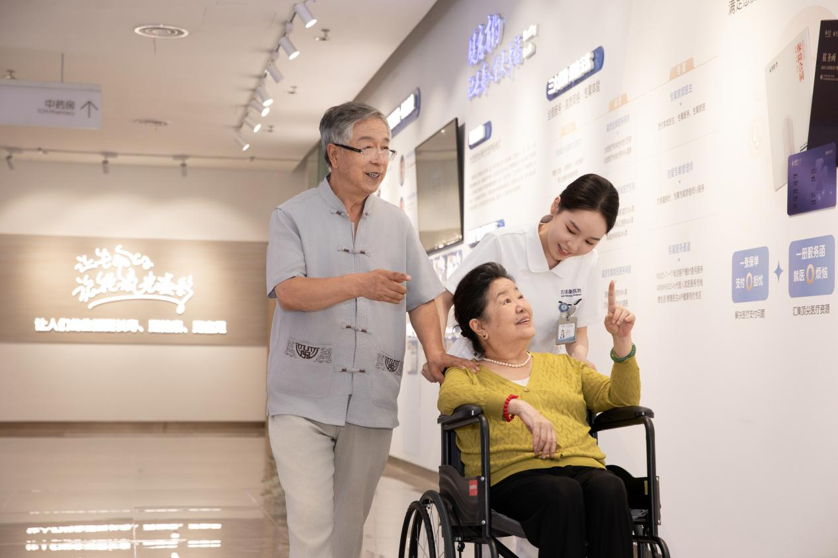
Guest-Centric, Five-Star Service Redefining the Healthcare Experience
At Sichuan Taikang Hospital's Specialized Medical Services Department, healthcare transforms from a clinical process into a journey of revered comfort.
International Remote Consultations: Leveraging resources from Taikang's five major medical centers, we provide consultations with renowned overseas medical institutions. Whether seeking expert opinions from international specialists or planning overseas treatment, our department offers personalized medical service plans.
Dedicated Customer Support Throughout: From appointment scheduling to consultations, examinations, and hospital admission, a dedicated medical concierge accompanies you every step of the way, ensuring seamless coordination and eliminating the hassle and confusion of navigating the process.
Private and Comfortable Treatment Spaces: Independent consultation areas, elegant waiting environments, and private examination rooms ensure maximum privacy. Hospital rooms are designed to high-end hotel standards, creating a peaceful and comfortable recovery environment.
Multilingual communication team: Our elite medical team comprises professionals from the US, Singapore, Japan, Saudi Arabia, and beyond, joined by seasoned specialists from top-tier provincial hospitals and international healthcare providers. We offer multilingual services in English, Arabic, Japanese, and more, alongside internationally standardized diagnostics and treatment.
Seamless Insurance Direct Billing: Partnering with multiple domestic and international premium health insurance providers, we offer direct billing services, freeing you from cumbersome financial arrangements so you can focus solely on your recovery.
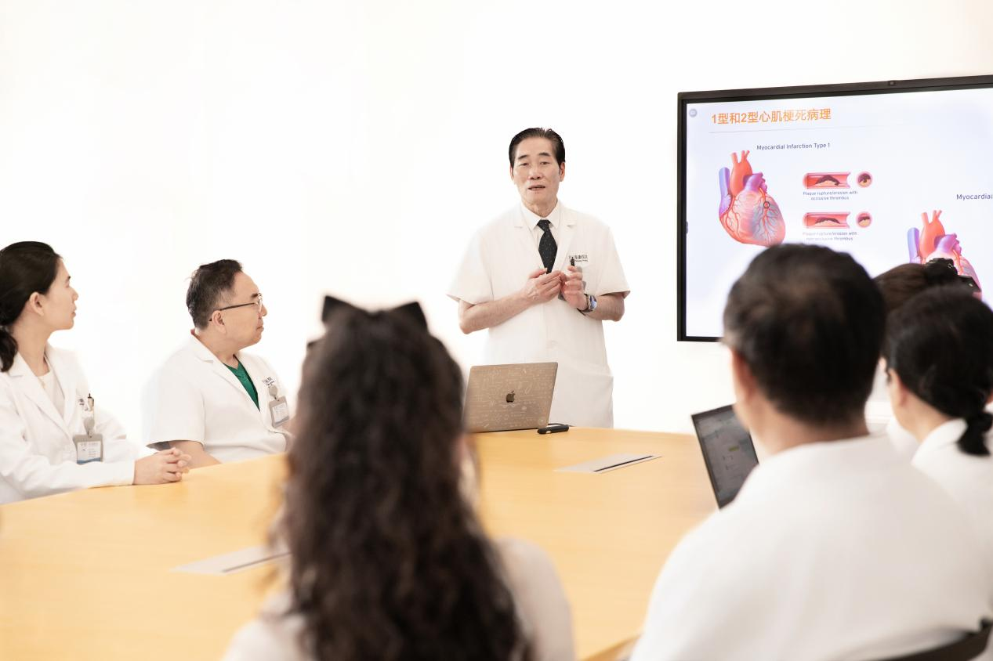
Taikang Healthcare Advantage: Building a Robust Healthcare Ecosystem
As a vital component of Taikang Healthcare, Sichuan Taikang Hospital not only mobilizes top-tier internal resources but also leverages the robust ecosystem of Taikang Insurance Group. We deliver integrated health solutions encompassing "Prevention-Diagnosis-Rehabilitation-Aging Care," safeguarding lifelong health and well-being.
The Specialized Medical Department at Sichuan Taikang Hospital delivers not only world-class medical technology but also a warmth and reassurance worthy of your trust. We invite you to experience firsthand the precision, composure, and dignity that healthcare should embody.
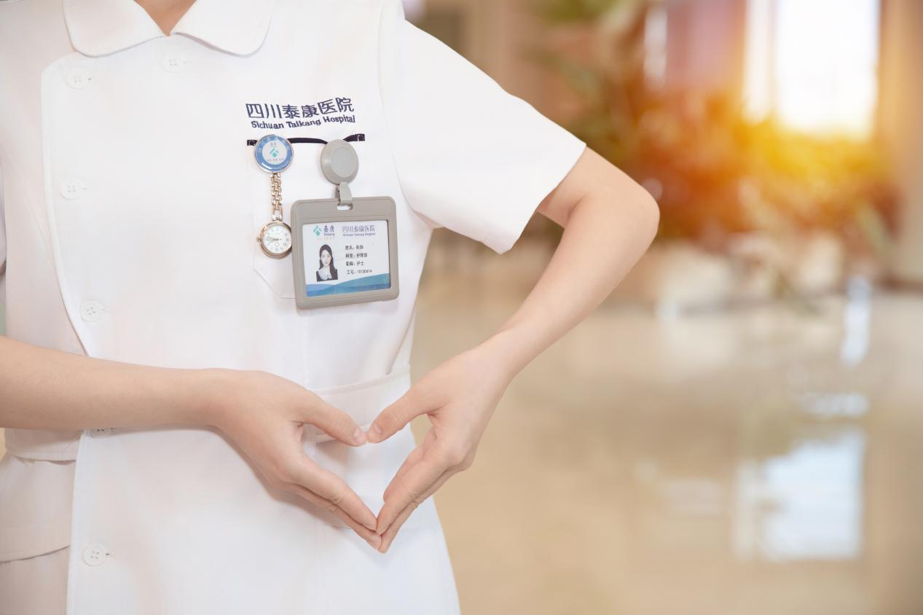
Sichuan Taikang Hospital
Sichuan Taikang Hospital is the first integrated tertiary general hospital combining medical care, education, and research established by Fortune Global 500 company Taikang Insurance Group in Southwest China. It stands as one of Taikang's five major medical centers. Located at No. 881 Xianghe 1st Street, Huayang Subdistrict, Tianfu New Area, Sichuan, it is designed according to the standards for domestic Class A tertiary general hospitals. With a total construction area of 185,000 square meters, it is planned to have 1,001 beds. The hospital features an "embedded" layout with the high-quality senior living community Taikang Home・Rongyuan, forming the Taikang Tianfu Medical and Senior Care Campus. With a total investment exceeding 4 billion yuan, it will become Southwest China's first super-scale integrated medical and senior care complex combining "medical care, education, research, senior care, and rehabilitation."
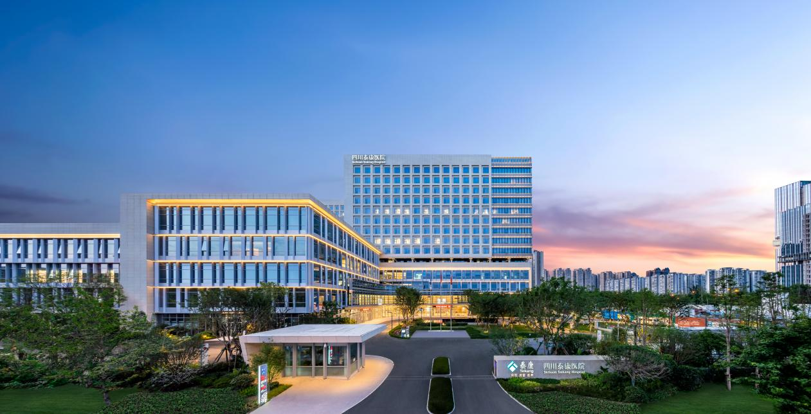
Medical Philosophy and Discipline Development: Guided by the principle of "Health-Centered Healthcare," the hospital prioritizes strategic disciplines including "Health Management and Geriatrics," alongside complementary fields such as "General Practice, Psychosomatic Medicine, Traditional Chinese Medicine, and Rehabilitation." Key focus areas encompass "Obstetrics & Gynecology/Pediatrics, Cardiovascular & Cerebrovascular Diseases, Oncology, and Palliative Care." It fully implements Taikang Healthcare's "5 + N" holistic discipline development model, establishing five strategic key disciplines: Health Management Center, Geriatric Medicine Center, Digestive Medicine Center, Urology Center, and Neurology Center. This builds a longevity healthcare system characterized by geriatric medicine, chronic disease management, and health management.
Service Model and Features: The hospital adheres to a patient-centered approach, integrating accessible healthcare with premium medical services to deliver multi-tiered care. As a practical implementation of insurance-backed healthcare, it supports direct insurance payments alongside medical insurance coverage, providing safe, efficient, and convenient services. Incorporating premium customer service principles into process design and operational planning, the hospital features dedicated VIP zones with 144 single-occupancy VIP rooms. A High-Value Customer Service Center provides specialized premium services including in-hospital navigation and expedited medical access.

